A Bootstrap 5 table is a regular HTML <table> enhanced with Bootstrap classes to make it responsive and visually appealing.

Basic Bootstrap 5 Table
<!DOCTYPE html>
<html lang="en">
<head>
<title>Bootstrap Table</title>
<meta charset="utf-8">
<meta name="viewport" content="width=device-width, initial-scale=1">

<!-- Bootstrap CSS -->
<link href="https://cdn.jsdelivr.net/npm/bootstrap@5.3.8/dist/css/bootstrap.min.css" rel="stylesheet">
</head>
<body>

<div class="container mt-4">
<h2>Student Details</h2>

<table class="table">
<thead>
<tr>
<th>ID</th>
<th>Name</th>
<th>Course</th>
<th>Marks</th>
</tr>
</thead>

<tbody>
<tr>
<td>101</td>
<td>Rahul</td>
<td>BCA</td>
<td>90</td>
</tr>

<tr>
<td>102</td>
<td>Priya</td>
<td>BSc</td>
<td>88</td>
</tr>

<tr>
<td>103</td>
<td>Amit</td>
<td>BCom</td>
<td>85</td>
</tr>
</tbody>
</table>

</div>

</body>
</html>

Common Bootstrap 5 Table Classes
Class | Description
table | Basic Bootstrap table
table-striped | Adds zebra-striped rows
table-bordered | Adds borders to all cells
table-borderless | Removes all borders
table-hover | Highlights a row when hovered
table-dark | Dark-themed table
table-sm | Makes the table more compact
table-responsive | Makes the table scroll horizontally on small screens

Example with Multiple Classes
<div class="container mt-4">

<table class="table table-striped table-bordered table-hover">
<thead class="table-dark">
<tr>
<th>ID</th>
<th>Name</th>
<th>Department</th>
<th>Salary</th>
</tr>
</thead>

<tbody>
<tr>
<td>1</td>
<td>John</td>
<td>HR</td>
<td>$5000</td>
</tr>

<tr>
<td>2</td>
<td>Emma</td>
<td>IT</td>
<td>$6500</td>
</tr>

<tr>
<td>3</td>
<td>David</td>
<td>Finance</td>
<td>$6000</td>
</tr>
</tbody>
</table>

</div>

Responsive Table
Wrap the table inside a table-responsive container.
<div class="table-responsive">
<table class="table table-bordered">
...
</table>
</div>
This allows horizontal scrolling on smaller screens instead of breaking the layout.

Colored Rows and Cells
Bootstrap provides contextual classes for rows or cells.
<table class="table">
<tr class="table-primary">
<td>Primary</td>
</tr>

<tr class="table-success">
<td>Success</td>
</tr>

<tr class="table-danger">
<td>Danger</td>
</tr>

<tr class="table-warning">
<td>Warning</td>
</tr>

<tr class="table-info">
<td>Info</td>
</tr>
</table>

Output Features
- table → Basic styling.
- table-striped → Alternate row colors.
- table-bordered → Borders around all cells.
- table-hover → Row highlight on hover.
- table-dark → Dark header or table.
- table-responsive → Mobile-friendly horizontal scrolling.
These classes can be combined as needed, for example:
<table class="table table-striped table-bordered table-hover table-sm">

Bootstrap 5 provides several classes to style and manage images.

1. Responsive Image (.img-fluid)
Makes the image resize automatically based on the screen size.

Example
<img src="image.jpg" class="img-fluid" alt="Responsive Image">
Explanation:
- img-fluid applies:
  - max-width: 100%;
  - height: auto;
- Prevents the image from overflowing its container.

2. Rounded Corners (.rounded)
Adds rounded corners to an image.

Example
<img src="image.jpg" class="rounded" alt="Rounded Image">
Output: Image with slightly rounded corners.

3. Circle Image (.rounded-circle)
Displays the image as a circle.

Example
<img src="image.jpg" class="rounded-circle" width="200" height="200" alt="Circle Image">
Note: Use a square image (equal width and height) for the best circular appearance.

4. Thumbnail (.img-thumbnail)
Displays the image with a border, padding, and rounded corners.

Example
<img src="image.jpg" class="img-thumbnail" alt="Thumbnail">
Output: Looks like a photo thumbnail.

5. Float Start (.float-start)
Aligns the image to the left.

Example
<img src="image.jpg" class="float-start" alt="Left Image">

6. Float End (.float-end)
Aligns the image to the right.

Example
<img src="image.jpg" class="float-end" alt="Right Image">

7. Center Image
Bootstrap doesn't have a dedicated class for centering images. Use utility classes with d-block.

Example
<img src="image.jpg" class="d-block mx-auto" alt="Centered Image">
Explanation:
- d-block makes the image a block element.
- mx-auto adds automatic left and right margins to center it.

8. Responsive Image with Rounded Corners
You can combine multiple Bootstrap classes.

Example
<img src="image.jpg" class="img-fluid rounded" alt="Responsive Rounded Image">

9. Responsive Circular Image
<img src="image.jpg" class="img-fluid rounded-circle" width="200" height="200" alt="Circular Image">

Complete Example
<!DOCTYPE html>
<html lang="en">
<head>
<title>Bootstrap 5 Images</title>
<meta charset="utf-8">
<meta name="viewport" content="width=device-width, initial-scale=1">

<!-- Bootstrap CSS -->
<link href="https://cdn.jsdelivr.net/npm/bootstrap@5.3.8/dist/css/bootstrap.min.css" rel="stylesheet">
</head>
<body>

<div class="container mt-4">

<h2>Responsive Image</h2>
<img src="image.jpg" class="img-fluid" alt="Responsive">

<hr>

<h2>Rounded Image</h2>
<img src="image.jpg" class="rounded" alt="Rounded">

<hr>

<h2>Circle Image</h2>
<img src="image.jpg" class="rounded-circle" width="200" height="200" alt="Circle">

<hr>

<h2>Thumbnail Image</h2>
<img src="image.jpg" class="img-thumbnail" alt="Thumbnail">

<hr>

<h2>Left Aligned</h2>
<img src="image.jpg" class="float-start" width="150" alt="Left">

<div class="clearfix"></div>

<hr>

<h2>Right Aligned</h2>
<img src="image.jpg" class="float-end" width="150" alt="Right">

<div class="clearfix"></div>

<hr>

<h2>Centered Image</h2>
<img src="image.jpg" class="d-block mx-auto" width="200" alt="Center">

</div>

</body>
</html>

Class | Purpose
.img-fluid | Makes the image responsive
.rounded | Adds rounded corners
.rounded-circle | Displays the image as a circle
.img-thumbnail | Adds a bordered thumbnail style
.float-start | Aligns the image to the left
.float-end | Aligns the image to the right
.d-block mx-auto | Centers the image horizontally
.img-fluid rounded | Responsive image with rounded corners
.img-fluid rounded-circle | Responsive circular image

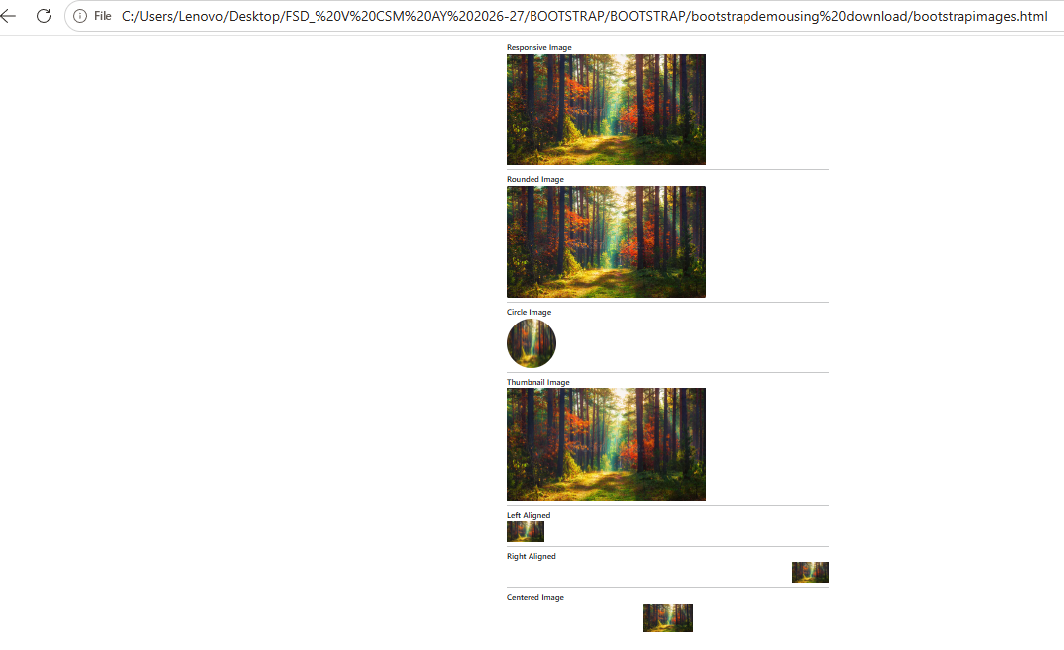

BOOTSTRAP FORMS

Bootstrap's Default Settings
Form controls automatically receive some global styling with Bootstrap:
All textual <input>, <textarea>, and <select> elements with class .form-control have a width of 100%

Bootstrap Form Layouts
Bootstrap provides three types of form layouts:
- Vertical form (this is default)
- Horizontal form
- Inline form
Standard rules for all three form layouts:
- Wrap labels and form controls in <div class="form-group"> (needed for optimum spacing)
- Add class .form-control to all textual <input>, <textarea>, and <select> elements

<!DOCTYPE html>
<html lang="en">

<head>
<title>Bootstrap Example</title>

<link href="https://cdn.jsdelivr.net/npm/bootstrap@5.2.1/dist/css/bootstrap.min.css" rel="stylesheet">

</head>

<body>
<div class="container">
<form>
<h1>Chaitanya Bharathi Institute of Technology (Autonomous)</h1>
<!-- EMAIL SUBMISSION -->
<div>
<label>Email address</label>
<input type="email" class="form-control" id="exampleInputEmail1" placeholder="Enter email">
<small >We'll never share your email with anyone else.</small>
</div>
<!-- PASSWORD -->
<div>
<label>Password</label>
<input type="password" class="form-control" id="Password" placeholder="Password">
</div>
<!-- DROPDOWN SELECT -->
<label>Select list (select one):</label>
<select class="form-select" id="select1" >
<option>1</option>
<option>2</option>
<option>3</option>
<option>4</option>
</select>
<!-- MULTIPLE SELECT OPTIONS -->
<label>Mutiple select list (Hold shift to select more than one):</label>
<select multiple class="form-select" id="select22">
<option>1</option>
<option>2</option>
<option>3</option>
<option>4</option>
<option>5</option>
</select>
<!-- TEXT AREA -->
<div>
<label>Comments:</label>
<textarea class="form-control" rows="5" id="comment"></textarea>
</div>
<!-- FILE UPLOAD INPUT -->
<div>
<label>File input</label>
<input type="file" class="form-control-file" id="InputFile">
</div>
<!-- RADIO BUTTONS -->
<fieldset>
<legend>Radio buttons</legend>
<div class="form-check">
<label class="form-check-label">
<input type="radio" class="form-check-input" name="optionsRadios" value="CBIT" checked>
CBIT
</label>
</div>
<div class="form-check">
<label class="form-check-label">
<input type="radio" class="form-check-input" name="optionsRadios" value="MGIT">
MGIT
</label>
</div>
<div class="form-check disabled">
<label class="form-check-label">
<input type="radio" class="form-check-input" name="optionsRadios" id="optionsRadios3" value="option3"
disabled>
VCE is disabled
</label>
</div>
</fieldset>
<!-- CHECK BUTTON -->
<div class="form-check">
<label class="form-check-label">
<input type="checkbox" class="form-check-input">
Check me out
</label>
</div>
<button type="submit" class="btn btn-primary">Submit</button>
</form>
</div>
</body>

</html>

BOOTSTRAP VALIDATION
<!DOCTYPE html>
<html lang="en">
<head>
<title>Bootstrap Example</title>
<meta charset="utf-8">
<meta name="viewport" content="width=device-width, initial-scale=1">
<link href="https://cdn.jsdelivr.net/npm/bootstrap@5.3.8/dist/css/bootstrap.min.css" rel="stylesheet">
<script src="https://cdn.jsdelivr.net/npm/bootstrap@5.3.8/dist/js/bootstrap.bundle.min.js"></script>
</head>
<body>

<div class="container mt-3">
<h3>Form Validation</h3>
<p>Try to submit the form.</p>

<form action="#" class="was-validated">
<div class="mb-3 mt-3">
<label for="uname" class="form-label">Username:</label>
<input type="text" class="form-control" id="uname" placeholder="Enter username" name="uname" required>
<div class="valid-feedback">Valid.</div>
<div class="invalid-feedback">Please fill out this field.</div>
</div>
<div class="mb-3">
<label for="pwd" class="form-label">Password:</label>
<input type="password" class="form-control" id="pwd" placeholder="Enter password" name="pswd" required>
<div class="valid-feedback">Valid.</div>
<div class="invalid-feedback">Please fill out this field.</div>
</div>
<div class="form-check mb-3">
<input class="form-check-input" type="checkbox" id="myCheck" name="remember" required>
<label class="form-check-label" for="myCheck">I agree .</label>
<div class="valid-feedback">Valid.</div>
<div class="invalid-feedback">Check this checkbox to continue.</div>
</div>
<button type="submit" class="btn btn-primary">Submit</button>
</form>
</div>

</body>
</html>

Bootstrap Alerts
Alerts are created with the .alert class, followed by one of the four contextual classes .alert-success, .alert-info, .alert-warning or .alert-danger:

<!DOCTYPE html>
<html lang="en">
<head>
<title>Bootstrap 5 Alerts Example</title>
<meta charset="utf-8">
<meta name="viewport" content="width=device-width, initial-scale=1">

<!-- Bootstrap 5 CSS -->
<link href="https://cdn.jsdelivr.net/npm/bootstrap@5.3.8/dist/css/bootstrap.min.css" rel="stylesheet">
</head>
<body>

<div class="container mt-4">
<h2>Alerts</h2>

<div class="alert alert-success" role="alert">
<strong>Success!</strong> This alert box could indicate a successful or positive action.
</div>

<div class="alert alert-info" role="alert">
<strong>Info!</strong> This alert box could indicate a neutral informative change or action.
</div>

<div class="alert alert-warning" role="alert">
<strong>Warning!</strong> This alert box could indicate a warning that might need attention.
</div>

<div class="alert alert-danger" role="alert">
<strong>Danger!</strong> This alert box could indicate a dangerous or potentially negative action.
</div>

</div>
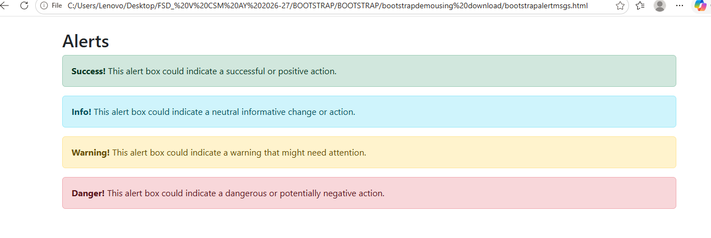

<!-- Bootstrap 5 JavaScript Bundle -->
<script src="https://cdn.jsdelivr.net/npm/bootstrap@5.3.8/dist/js/bootstrap.bundle.min.js"></script>

</body>
</html>

Creating Alert Messages with Bootstrap
Alert boxes are used quite often to stand out the information that requires immediate attention of the end users such as warning, error or confirmation messages.
With Bootstrap you can easily create elegant alert messages for various purposes by adding the contextual classes (e.g., .alert-success, .alert-warning, .alert-info etc.) to the .alert base class. You can also add an optional close button to dismiss any alert.

ALERT TYPES IN HTML

<!DOCTYPE html>
<html lang="en">
<head>
<meta charset="utf-8">
<meta name="viewport" content="width=device-width, initial-scale=1">
<title>Bootstrap New Alert Boxes</title>
<link href="https://cdn.jsdelivr.net/npm/bootstrap@5.0.2/dist/css/bootstrap.min.css" rel="stylesheet">
<script src="https://cdn.jsdelivr.net/npm/bootstrap@5.0.2/dist/js/bootstrap.bundle.min.js"></script>
</head>
<body>
<div class="m-4">
<!-- Primary Alert -->
<div class="alert alert-primary alert-dismissible fade show">
<strong>Primary!</strong> This is a simple primary alert box.
<button type="button" class="btn-close" data-bs-dismiss="alert"></button>
</div>

<!-- Secondary Alert -->
<div class="alert alert-secondary alert-dismissible fade show">
<strong>Secondary!</strong> This is a simple secondary alert box.
<button type="button" class="btn-close" data-bs-dismiss="alert"></button>
</div>

<!-- Dark Alert -->
<div class="alert alert-dark alert-dismissible fade show">
<strong>Dark!</strong> This is a simple dark alert box.
<button type="button" class="btn-close" data-bs-dismiss="alert"></button>
</div>

<!-- Light Alert -->
<div class="alert alert-light alert-dismissible fade show">
<strong>Light!</strong> This is a simple light alert box.
<button type="button" class="btn-close" data-bs-dismiss="alert"></button>
</div>
</div>
</body>
</html>

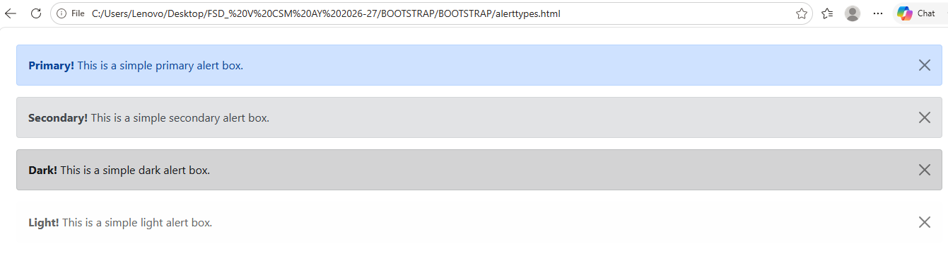

Matching Links Color inside Alerts
You can apply the utility class .alert-link to the links inside any alert boxes to quickly create matching colored links, as shown in the example below:

<!DOCTYPE html>
<html lang="en">
<head>
<meta charset="utf-8">
<meta name="viewport" content="width=device-width, initial-scale=1">
<title>Link inside Bootstrap Alerts</title>
<link href="https://cdn.jsdelivr.net/npm/bootstrap@5.0.2/dist/css/bootstrap.min.css" rel="stylesheet">
<script src="https://cdn.jsdelivr.net/npm/bootstrap@5.0.2/dist/js/bootstrap.bundle.min.js"></script>
</head>
<body>
<div class="m-4">
<div class="alert alert-warning alert-dismissible fade show">
<strong>Warning!</strong> A simple warning alert with <a href="#" class="alert-link">an example link</a>.
<button type="button" class="btn-close" data-bs-dismiss="alert"></button>
</div>
</div>
</body>
</html>

<!DOCTYPE html>
<html lang="en">
<head>
<meta charset="utf-8">
<meta name="viewport" content="width=device-width, initial-scale=1">
<title>Matching Links Color inside Bootstrap Alerts</title>
<link href="https://cdn.jsdelivr.net/npm/bootstrap@5.0.2/dist/css/bootstrap.min.css" rel="stylesheet">
<script src="https://cdn.jsdelivr.net/npm/bootstrap@5.0.2/dist/js/bootstrap.bundle.min.js"></script>
</head>
<body>
<div class="m-4">
<!-- Success Alert -->
<div class="alert alert-success alert-dismissible fade show">
<strong>Success!</strong> A simple success alert with <a href="#" class="alert-link">an example link</a>.
<button type="button" class="btn-close" data-bs-dismiss="alert"></button>
</div>

<!-- Error Alert -->
<div class="alert alert-danger alert-dismissible fade show">
<strong>Error!</strong> A simple danger alert with <a href="#" class="alert-link">an example link</a>.
<button type="button" class="btn-close" data-bs-dismiss="alert"></button>
</div>

<!-- Warning Alert -->
<div class="alert alert-warning alert-dismissible fade show">
<strong>Warning!</strong> A simple warning alert with <a href="#" class="alert-link">an example link</a>.
<button type="button" class="btn-close" data-bs-dismiss="alert"></button>
</div>

<!-- Info Alert -->
<div class="alert alert-info alert-dismissible fade show">
<strong>Info!</strong> A simple info alert with <a href="#" class="alert-link">an example link</a>.
<button type="button" class="btn-close" data-bs-dismiss="alert"></button>
</div>

<!-- Primary Alert -->
<div class="alert alert-primary alert-dismissible fade show">
<strong>Primary!</strong> A simple primary alert with <a href="#" class="alert-link">an example link</a>.
<button type="button" class="btn-close" data-bs-dismiss="alert"></button>
</div>

<!-- Secondary Alert -->
<div class="alert alert-secondary alert-dismissible fade show">
<strong>Secondary!</strong> A simple secondary alert with <a href="#" class="alert-link">an example link</a>.
<button type="button" class="btn-close" data-bs-dismiss="alert"></button>
</div>

<!-- Dark Alert -->
<div class="alert alert-dark alert-dismissible fade show">
<strong>Dark!</strong> A simple dark alert with <a href="#" class="alert-link">an example link</a>.
<button type="button" class="btn-close" data-bs-dismiss="alert"></button>
</div>

<!-- Light Alert -->
<div class="alert alert-light alert-dismissible fade show">
<strong>Light!</strong> A simple light alert with <a href="#" class="alert-link">an example link</a>.
<button type="button" class="btn-close" data-bs-dismiss="alert"></button>
</div>
</div>
</body>
</html>

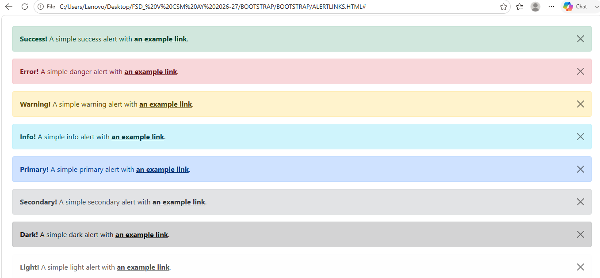

Navbar
Bootstrap navbar component to create responsive navigation header for your website or application.
<!DOCTYPE html>
<html lang="en">
<head>
<meta charset="utf-8">
<meta name="viewport" content="width=device-width, initial-scale=1">
<title>Bootstrap Static Navbar</title>
<link href="https://cdn.jsdelivr.net/npm/bootstrap@5.0.2/dist/css/bootstrap.min.css" rel="stylesheet">
<script src="https://cdn.jsdelivr.net/npm/bootstrap@5.0.2/dist/js/bootstrap.bundle.min.js"></script>
</head>
<body>
<div class="m-4">
<nav class="navbar navbar-expand-lg navbar-light bg-light">
<div class="container-fluid">
<a href="#" class="navbar-brand">Brand</a>
<button type="button" class="navbar-toggler" data-bs-toggle="collapse" data-bs-target="#navbarCollapse">
<span class="navbar-toggler-icon"></span>
</button>
<div class="collapse navbar-collapse" id="navbarCollapse">
<div class="navbar-nav">
<a href="#" class="nav-item nav-link active">Home</a>
<a href="#" class="nav-item nav-link">Profile</a>
<a href="#" class="nav-item nav-link">Messages</a>
<a href="#" class="nav-item nav-link disabled" tabindex="-1">Reports</a>
</div>
<div class="navbar-nav ms-auto">
<a href="#" class="nav-item nav-link">Login</a>
</div>
</div>
</div>
</nav>
</div>
</body>
</html>

Adding Logo Images to Navbars
You can also place your logo image inside the navbar, instead of plain text.
<!DOCTYPE html>
<html lang="en">
<head>
<meta charset="utf-8">
<meta name="viewport" content="width=device-width, initial-scale=1">
<title>Bootstrap Navbar with Logo Image</title>
<link href="https://cdn.jsdelivr.net/npm/bootstrap@5.0.2/dist/css/bootstrap.min.css" rel="stylesheet">
<script src="https://cdn.jsdelivr.net/npm/bootstrap@5.0.2/dist/js/bootstrap.bundle.min.js"></script>
</head>
<body>
<div class="m-4">
<nav class="navbar navbar-expand-lg navbar-light bg-light">
<div class="container-fluid">
<a href="#" class="navbar-brand">
<img src="/examples/images/logo.svg" height="28" alt="CoolBrand">
</a>
<button type="button" class="navbar-toggler" data-bs-toggle="collapse" data-bs-target="#navbarCollapse">
<span class="navbar-toggler-icon"></span>
</button>
<div class="collapse navbar-collapse" id="navbarCollapse">
<div class="navbar-nav">
<a href="#" class="nav-item nav-link active">Home</a>
<a href="#" class="nav-item nav-link">Profile</a>
<a href="#" class="nav-item nav-link">Messages</a>
<a href="#" class="nav-item nav-link disabled" tabindex="-1">Reports</a>
</div>
<div class="navbar-nav ms-auto">
<a href="#" class="nav-item nav-link">Login</a>
</div>
</div>
</div>
</nav>
</div>
</body>
</html>
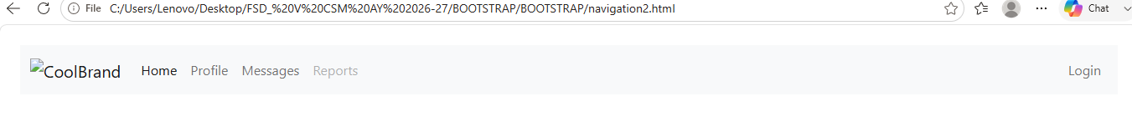

Adding Dropdowns to Navbar
You can also include dropdowns and search box within the navbars, as shown here:
<!DOCTYPE html>
<html lang="en">
<head>
<meta charset="utf-8">
<meta name="viewport" content="width=device-width, initial-scale=1">
<title>Bootstrap Navbar with Dropdown</title>
<link href="https://cdn.jsdelivr.net/npm/bootstrap@5.0.2/dist/css/bootstrap.min.css" rel="stylesheet">
<script src="https://cdn.jsdelivr.net/npm/bootstrap@5.0.2/dist/js/bootstrap.bundle.min.js"></script>
</head>
<body>
<div class="m-4">
<nav class="navbar navbar-expand-lg navbar-light bg-light">
<div class="container-fluid">
<a href="#" class="navbar-brand">Brand</a>
<button type="button" class="navbar-toggler" data-bs-toggle="collapse" data-bs-target="#navbarCollapse">
<span class="navbar-toggler-icon"></span>
</button>
<div class="collapse navbar-collapse" id="navbarCollapse">
<div class="navbar-nav">
<a href="#" class="nav-item nav-link active">Home</a>
<a href="#" class="nav-item nav-link">Profile</a>
<div class="nav-item dropdown">
<a href="#" class="nav-link dropdown-toggle" data-bs-toggle="dropdown">Messages</a>
<div class="dropdown-menu">
<a href="#" class="dropdown-item">Inbox</a>
<a href="#" class="dropdown-item">Sent</a>
<a href="#" class="dropdown-item">Drafts</a>
</div>
</div>
<a href="#" class="nav-item nav-link disabled" tabindex="-1">Reports</a>
</div>
<div class="navbar-nav ms-auto">
<a href="#" class="nav-item nav-link">Login</a>
</div>
</div>
</div>
</nav>
</div>
</body>
</html>
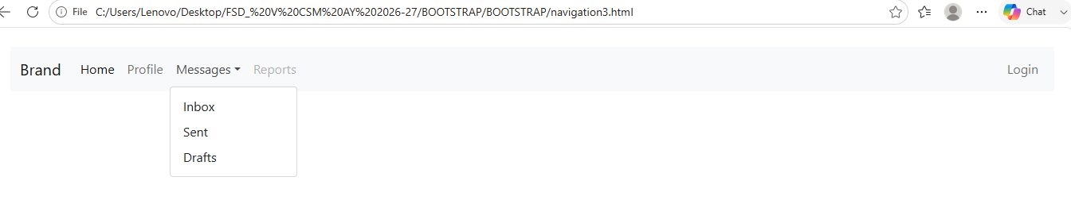

Placing Search Form inside Navbar
Search form is a very common component of the navbars and you have seen it on various website quite often. You can place various form controls within a navbar using the class .d-flex on the <form> element, as demonstrated in the following example:
<!DOCTYPE html>
<html lang="en">
<head>
<meta charset="utf-8">
<meta name="viewport" content="width=device-width, initial-scale=1">
<title>Bootstrap Navbar with Dropdown</title>
<link href="https://cdn.jsdelivr.net/npm/bootstrap@5.0.2/dist/css/bootstrap.min.css" rel="stylesheet">
<link rel="stylesheet" href="https://cdn.jsdelivr.net/npm/bootstrap-icons@1.5.0/font/bootstrap-icons.css">
<script src="https://cdn.jsdelivr.net/npm/bootstrap@5.0.2/dist/js/bootstrap.bundle.min.js"></script>
</head>
<body>
<div class="m-4">
<nav class="navbar navbar-expand-lg navbar-light bg-light">
<div class="container-fluid">
<a href="#" class="navbar-brand">Brand</a>
<button type="button" class="navbar-toggler" data-bs-toggle="collapse" data-bs-target="#navbarCollapse">
<span class="navbar-toggler-icon"></span>
</button>
<div class="collapse navbar-collapse justify-content-between" id="navbarCollapse">
<div class="navbar-nav">
<a href="#" class="nav-item nav-link active">Home</a>
<a href="#" class="nav-item nav-link">Profile</a>
<div class="nav-item dropdown">
<a href="#" class="nav-link dropdown-toggle" data-bs-toggle="dropdown">Messages</a>
<div class="dropdown-menu">
<a href="#" class="dropdown-item">Inbox</a>
<a href="#" class="dropdown-item">Sent</a>
<a href="#" class="dropdown-item">Drafts</a>
</div>
</div>
</div>
<form class="d-flex">
<div class="input-group">
<input type="text" class="form-control" placeholder="Search">
<button type="button" class="btn btn-secondary"><i class="bi-search"></i></button>
</div>
</form>
<div class="navbar-nav">
<a href="#" class="nav-item nav-link">Login</a>
</div>
</div>
</div>
</nav>
</div>
</body>
</html>
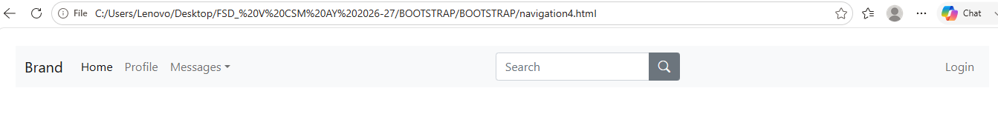

Changing the Color Scheme of Navbars
You can also change the color scheme of the navbar by using the .navbar-light for the light background colors, or .navbar-dark for the dark background colors. Then, customize it with the background color utility classes, such as .bg-dark, .bg-primary, and so on.
Alternatively, you can also apply the CSS background-color property on the .navbar element yourself to customize the navbar theme, as shown in the following example:
<!DOCTYPE html>
<html lang="en">
<head>
<meta charset="utf-8">
<meta name="viewport" content="width=device-width, initial-scale=1">
<title>Bootstrap Navbar Color Schemes</title>
<link href="https://cdn.jsdelivr.net/npm/bootstrap@5.0.2/dist/css/bootstrap.min.css" rel="stylesheet">
<link rel="stylesheet" href="https://cdn.jsdelivr.net/npm/bootstrap-icons@1.5.0/font/bootstrap-icons.css">
<script src="https://cdn.jsdelivr.net/npm/bootstrap@5.0.2/dist/js/bootstrap.bundle.min.js"></script>
<style>
/* Custom style */
.navbar{
margin-bottom: 1rem;
}
</style>
</head>
<body>
<div class="m-4">
<nav class="navbar navbar-expand-lg navbar-dark bg-dark">
<div class="container-fluid">
<a href="#" class="navbar-brand">Brand</a>
<button type="button" class="navbar-toggler" data-bs-toggle="collapse" data-bs-target="#navbarCollapse1">
<span class="navbar-toggler-icon"></span>
</button>
<div class="collapse navbar-collapse" id="navbarCollapse1">
<div class="navbar-nav">
<a href="#" class="nav-item nav-link active">Home</a>
<a href="#" class="nav-item nav-link">About</a>
<a href="#" class="nav-item nav-link">Products</a>
</div>
<form class="d-flex ms-auto">
<input type="text" class="form-control me-sm-2" placeholder="Search">
<button type="submit" class="btn btn-outline-light">Search</button>
</form>
</div>
</div>
</nav>

<nav class="navbar navbar-expand-lg navbar-dark bg-primary">
<div class="container-fluid">
<a href="#" class="navbar-brand">Brand</a>
<button type="button" class="navbar-toggler" data-bs-toggle="collapse" data-bs-target="#navbarCollapse2">
<span class="navbar-toggler-icon"></span>
</button>
<div class="collapse navbar-collapse" id="navbarCollapse2">
<div class="navbar-nav">
<a href="#" class="nav-item nav-link active">Home</a>
<a href="#" class="nav-item nav-link">About</a>
<a href="#" class="nav-item nav-link">Products</a>
</div>
<form class="d-flex ms-auto">
<input type="text" class="form-control me-sm-2" placeholder="Search">
<button type="submit" class="btn btn-outline-light">Search</button>
</form>
</div>
</div>
</nav>

<nav class="navbar navbar-expand-lg navbar-dark bg-secondary">
<div class="container-fluid">
<a href="#" class="navbar-brand">Brand</a>
<button type="button" class="navbar-toggler" data-bs-toggle="collapse" data-bs-target="#navbarCollapse3">
<span class="navbar-toggler-icon"></span>
</button>
<div class="collapse navbar-collapse" id="navbarCollapse3">
<div class="navbar-nav">
<a href="#" class="nav-item nav-link active">Home</a>
<a href="#" class="nav-item nav-link">About</a>
<a href="#" class="nav-item nav-link">Products</a>
</div>
<form class="d-flex ms-auto">
<input type="text" class="form-control me-sm-2" placeholder="Search">
<button type="submit" class="btn btn-outline-light">Search</button>
</form>
</div>
</div>
</nav>

<nav class="navbar navbar-expand-lg navbar-dark bg-success">
<div class="container-fluid">
<a href="#" class="navbar-brand">Brand</a>
<button type="button" class="navbar-toggler" data-bs-toggle="collapse" data-bs-target="#navbarCollapse4">
<span class="navbar-toggler-icon"></span>
</button>
<div class="collapse navbar-collapse" id="navbarCollapse4">
<div class="navbar-nav">
<a href="#" class="nav-item nav-link active">Home</a>
<a href="#" class="nav-item nav-link">About</a>
<a href="#" class="nav-item nav-link">Products</a>
</div>
<form class="d-flex ms-auto">
<input type="text" class="form-control me-sm-2" placeholder="Search">
<button type="submit" class="btn btn-outline-light">Search</button>
</form>
</div>
</div>
</nav>

<nav class="navbar navbar-expand-lg navbar-dark bg-info">
<div class="container-fluid">
<a href="#" class="navbar-brand">Brand</a>
<button type="button" class="navbar-toggler" data-bs-toggle="collapse" data-bs-target="#navbarCollapse5">
<span class="navbar-toggler-icon"></span>
</button>
<div class="collapse navbar-collapse" id="navbarCollapse5">
<div class="navbar-nav">
<a href="#" class="nav-item nav-link active">Home</a>
<a href="#" class="nav-item nav-link">About</a>
<a href="#" class="nav-item nav-link">Products</a>
</div>
<form class="d-flex ms-auto">
<input type="text" class="form-control me-sm-2" placeholder="Search">
<button type="submit" class="btn btn-outline-light">Search</button>
</form>
</div>
</div>
</nav>

<nav class="navbar navbar-expand-lg navbar-dark bg-danger">
<div class="container-fluid">
<a href="#" class="navbar-brand">Brand</a>
<button type="button" class="navbar-toggler" data-bs-toggle="collapse" data-bs-target="#navbarCollapse6">
<span class="navbar-toggler-icon"></span>
</button>
<div class="collapse navbar-collapse" id="navbarCollapse6">
<div class="navbar-nav">
<a href="#" class="nav-item nav-link active">Home</a>
<a href="#" class="nav-item nav-link">About</a>
<a href="#" class="nav-item nav-link">Products</a>
</div>
<form class="d-flex ms-auto">
<input type="text" class="form-control me-sm-2" placeholder="Search">
<button type="submit" class="btn btn-outline-light">Search</button>
</form>
</div>
</div>
</nav>

<nav class="navbar navbar-expand-lg navbar-dark bg-warning">
<div class="container-fluid">
<a href="#" class="navbar-brand">Brand</a>
<button type="button" class="navbar-toggler" data-bs-toggle="collapse" data-bs-target="#navbarCollapse7">
<span class="navbar-toggler-icon"></span>
</button>
<div class="collapse navbar-collapse" id="navbarCollapse7">
<div class="navbar-nav">
<a href="#" class="nav-item nav-link active">Home</a>
<a href="#" class="nav-item nav-link">About</a>
<a href="#" class="nav-item nav-link">Products</a>
</div>
<form class="d-flex ms-auto">
<input type="text" class="form-control me-sm-2" placeholder="Search">
<button type="submit" class="btn btn-outline-light">Search</button>
</form>
</div>
</div>
</nav>

<nav class="navbar navbar-expand-lg navbar-light bg-light">
<div class="container-fluid">
<a href="#" class="navbar-brand">Brand</a>
<button type="button" class="navbar-toggler" data-bs-toggle="collapse" data-bs-target="#navbarCollapse8">
<span class="navbar-toggler-icon"></span>
</button>
<div class="collapse navbar-collapse" id="navbarCollapse8">
<div class="navbar-nav">
<a href="#" class="nav-item nav-link active">Home</a>
<a href="#" class="nav-item nav-link">About</a>
<a href="#" class="nav-item nav-link">Products</a>
</div>
<form class="d-flex ms-auto">
<input type="text" class="form-control me-sm-2" placeholder="Search">
<button type="submit" class="btn btn-outline-secondary">Search</button>
</form>
</div>
</div>
</nav>

<nav class="navbar navbar-expand-lg navbar-light" style="background-color: #e3f2fd;">
<div class="container-fluid">
<a href="#" class="navbar-brand">Brand</a>
<button type="button" class="navbar-toggler" data-bs-toggle="collapse" data-bs-target="#navbarCollapse9">
<span class="navbar-toggler-icon"></span>
</button>
<div class="collapse navbar-collapse" id="navbarCollapse9">
<div class="navbar-nav">
<a href="#" class="nav-item nav-link active">Home</a>
<a href="#" class="nav-item nav-link">About</a>
<a href="#" class="nav-item nav-link">Products</a>
</div>
<form class="d-flex ms-auto">
<input type="text" class="form-control me-sm-2" placeholder="Search">
<button type="submit" class="btn btn-outline-primary">Search</button>
</form>
</div>
</div>
</nav>
</div>
</body>
</html>
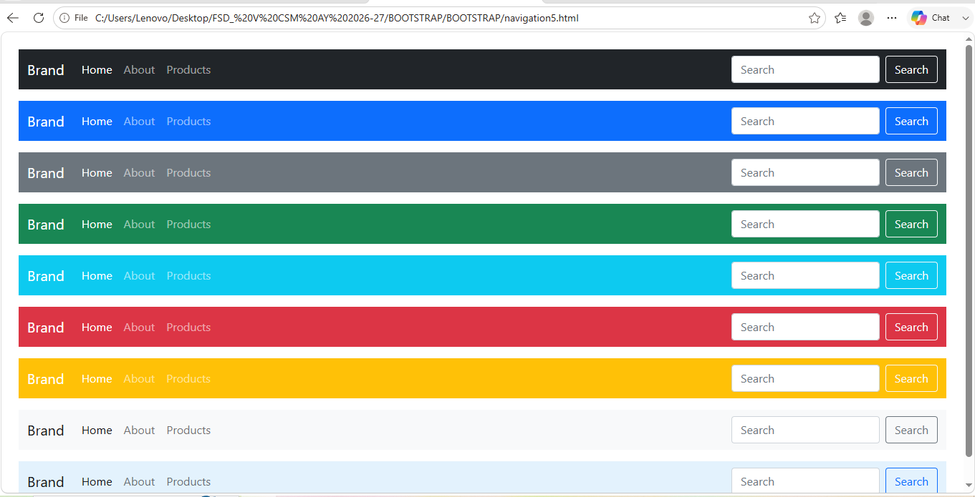

Bootstrap Fixed Navbars
Bootstrap also provides mechanism to create navbar that is fixed to the top, fixed to the bottom, or stickied to the top (i.e. scrolls with the page until it reaches the top, then stays there).

Navbar Fixed to the Top
Apply the position utility class .fixed-top to the .navbar element to fix the navbar at the top of the viewport, so that it won't scroll with the page. Here's an example:

<!DOCTYPE html>
<html lang="en">
<head>
<meta charset="utf-8">
<meta name="viewport" content="width=device-width, initial-scale=1">
<title>Bootstrap Navbar Fixed to Top</title>
<link href="https://cdn.jsdelivr.net/npm/bootstrap@5.0.2/dist/css/bootstrap.min.css" rel="stylesheet">
<script src="https://cdn.jsdelivr.net/npm/bootstrap@5.0.2/dist/js/bootstrap.bundle.min.js"></script>
<style>
/* Custom CSS to prevent the content
to go underneath the navbar */
body{
padding-top: 70px;
}
</style>
</head>
<body>
<div class="m-4">
<nav class="navbar fixed-top navbar-expand-lg navbar-dark bg-dark">
<div class="container-fluid">
<a href="#" class="navbar-brand">Brand</a>
<button type="button" class="navbar-toggler" data-bs-toggle="collapse" data-bs-target="#navbarCollapse">
<span class="navbar-toggler-icon"></span>
</button>
<div class="collapse navbar-collapse" id="navbarCollapse">
<div class="navbar-nav">
<a href="#" class="nav-item nav-link active">Home</a>
<a href="#" class="nav-item nav-link">Profile</a>
<a href="#" class="nav-item nav-link">Messages</a>
<a href="#" class="nav-item nav-link disabled" tabindex="-1">Reports</a>
</div>
<div class="navbar-nav ms-auto">
<a href="#" class="nav-item nav-link">Login</a>
</div>
</div>
</div>
</nav>

<!-- Demo Content -->
<div class="container">
<div class="p-5 mb-4 bg-light rounded-3">
<h1>Fixed Top Navbar</h1>
<p class="lead">The fixed-top navbar bar is fixed at the top of the viewport and does not scroll with the rest of the page.</p>
</div>
<p>Lorem ipsum dolor sit amet, consectetur adipiscing elit. Nam eu sem tempor, varius quam at, luctus dui. Mauris magna metus, dapibus nec turpis vel, semper malesuada ante. Vestibulum id metus ac nisl bibendum scelerisque non non purus. Suspendisse varius nibh non aliquet sagittis. In tincidunt orci sit amet elementum vestibulum. Vivamus fermentum in arcu in aliquam. Quisque aliquam porta odio in fringilla. Vivamus nisl leo, blandit at bibendum eu, tristique eget risus. Integer aliquet quam ut elit suscipit, id interdum neque porttitor. Integer faucibus ligula.Quis quam ut magna consequat faucibus. Pellentesque eget nisi a mi suscipit tincidunt. Ut tempus dictum risus. Pellentesque viverra sagittis quam at mattis. Suspendisse potenti. Aliquam sit amet gravida nibh, facilisis gravida odio. Phasellus auctor velit at lacus blandit, commodo iaculis justo viverra. Etiam vitae est arcu. Mauris vel congue dolor. Aliquam eget mi mi. Fusce quam tortor, commodo ac dui quis, bibendum viverra erat. Maecenas mattis lectus enim, quis tincidunt dui molestie euismod. Curabitur et diam tristique, accumsan nunc eu, hendrerit tellus. Tibulum consectetur scelerisque lacus, ac fermentum lorem convallis sed.</p>
<p>Orci facilisis, dignissim tortor vitae, ultrices mi. Vestibulum a iaculis lacus. Phasellus vitae convallis ligula, nec volutpat tellus. Vivamus scelerisque mollis nisl, nec vehicula elit egestas a. Sed luctus metus id mi gravida, faucibus convallis neque pretium. Maecenas quis sapien ut leo fringilla tempor vitae sit amet leo. Donec imperdiet tempus placerat. Pellentesque pulvinar ultrices nunc sed ultrices. Morbi vel mi pretium, fermentum lacus et, viverra tellus. Phasellus sodales libero nec dui convallis, sit amet fermentum sapien auctor. Vestibulum ante ipsum primis in faucibus orci luctus et ultrices posuere cubilia Curae; Sed eu elementum nibh, quis varius libero.Nam eget purus nec est consectetur vehicula. Nullam ultrices nisl risus, in viverra libero egestas sit amet. Etiam porttitor dolor non eros pulvinar malesuada. Vestibulum sit amet est mollis nulla tempus aliquet. Praesent luctus hendrerit arcu non laoreet. Morbi consequat placerat magna, ac ornare odio sagittis sed. Donec vitae ullamcorper purus. Vivamus non metus ac justo porta volutpat.</p>
<p>Pulvinar leo id risus pellentesque vestibulum. Sed diam libero, sodales eget sapien vel, porttitor bibendum enim. Donec sed nibh vitae lorem porttitor blandit in nec ante. Pellentesque vitae metus ipsum. Phasellus sed nunc ac sem malesuada condimentum. Etiam in aliquam lectus. Nam vel sapien diam. Donec pharetra id arcu eget blandit. Proin imperdiet mattis augue in porttitor. Quisque tempus enim id lobortis feugiat. Suspendisse tincidunt risus quis dolor fringilla blandit. Ut sed sapien at purus lacinia porttitor. Nullam iaculis, felis a pretium ornare, dolor nisl semper tortor, vel sagittis lacus est consequat eros. Sed id pretium nisl. Curabitur dolor nisl, laoreet vitae aliquam id.Nullam hendrerit justo non leo aliquet imperdiet. Etiam in sagittis lectus. Suspendisse ultrices placerat accumsan. Mauris quis dapibus orci. In dapibus velit blandit pharetra tincidunt. Quisque non sapien nec lacus condimentum facilisis ut iaculis enim. Sed viverra interdum bibendum. Donec ac sollicitudin dolor. Sed fringilla vitae lacus at rutrum. Phasellus congue vestibulum ligula sed consequat.</p>
<p>Enim arcu, interdum vel metus dignissim, venenatis feugiat purus. Nulla posuere orci ut leo sodales, sed cursus dolor ornare. Cum sociis natoque penatibus et magnis dis parturient montes, nascetur ridiculus mus. Etiam sit amet quam orci. Nulla sollicitudin lectus eget posuere venenatis. Sed vestibulum elementum sagittis. Quisque tristique tortor quis feugiat sollicitudin. Ut pellentesque luctus vulputate. Ut at odio ac erat blandit vehicula ut eget urna. In hac habitasse platea dictumst. Nullam ut iaculis nibh, eget eleifend elit.Convallis eget pretium eu, bibendum non leo. Proin suscipit purus adipiscing dolor gravida, in fermentum sapien blandit. Praesent pellentesque ligula dui, in gravida turpis vehicula ac. Pellentesque hendrerit nunc ut luctus hendrerit. Aliquam nec tincidunt urna. Ut interdum nec odio non interdum. Curabitur ligula justo, dapibus non ligula tristique, dapibus tristique nulla. Aliquam pulvinar dapibus eros, rutrum pretium urna iaculis ut. Nam est est, tempus id egestas et, viverra in dui. Aliquam gravida orci tortor, sed congue justo ornare vel. Cras in quam consectetur eros varius scelerisque. Ut vel fermentum purus. Nullam interdum blandit turpis, id pellentesque massa feugiat at. Ut sed lectus lectus. Vestibulum ante ipsum primis in faucibus orci luctus et ultrices posuere cubilia Curae; Nulla rutrum, ante quis convallis ultricies, magna quam rhoncus erat, in lacinia libero magna a ipsum.</p>
<p>Fusce enim arcu, interdum vel metus dignissim, venenatis feugiat purus. Nulla posuere orci ut leo sodales, sed cursus dolor ornare. Cum sociis natoque penatibus et magnis dis parturient montes, nascetur ridiculus mus. Etiam sit amet quam orci. Nulla sollicitudin lectus eget posuere venenatis. Sed vestibulum elementum sagittis. Quisque tristique tortor quis feugiat sollicitudin. Ut pellentesque luctus vulputate. Ut at odio ac erat blandit vehicula ut eget urna. In hac habitasse platea dictumst. Nullam ut iaculis nibh, eget eleifend elit.</p>
</div>
</div>
</body>
</html>

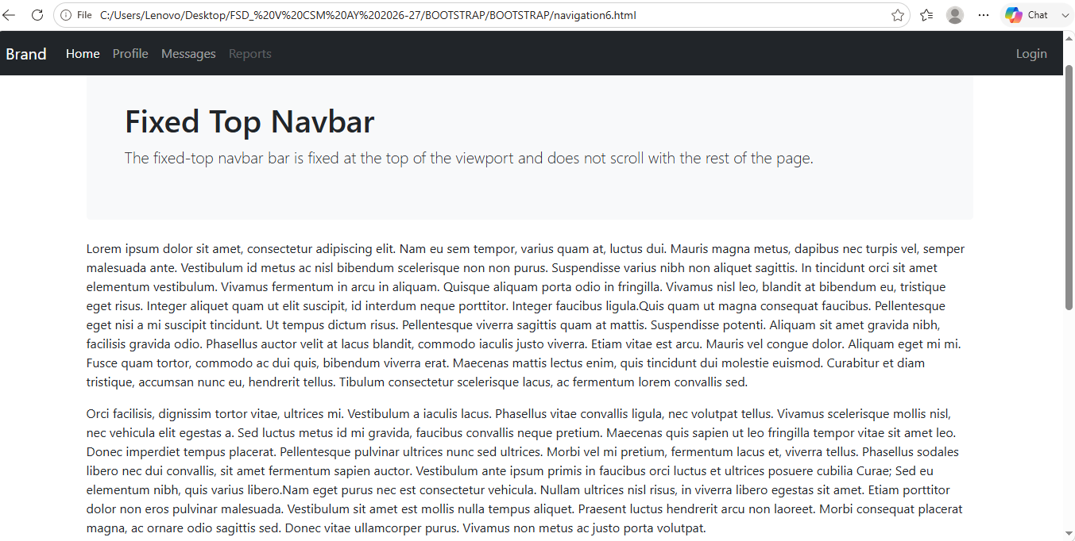

Navbar Fixed to the Bottom
Similarly, add the class .fixed-bottom to the .navbar element to fix the navbar at the bottom of the viewport. It also won't scroll with the page. Let's see how it works:
<!DOCTYPE html>
<html lang="en">
<head>
<meta charset="utf-8">
<meta name="viewport" content="width=device-width, initial-scale=1">
<title>Bootstrap Navbar Fixed to Bottom</title>
<link href="https://cdn.jsdelivr.net/npm/bootstrap@5.0.2/dist/css/bootstrap.min.css" rel="stylesheet">
<script src="https://cdn.jsdelivr.net/npm/bootstrap@5.0.2/dist/js/bootstrap.bundle.min.js"></script>
<style>
/* Custom CSS to prevent the content
to go underneath the navbar */
body{
padding-bottom: 70px;
}
</style>
</head>
<body>
<div class="m-4">
<nav class="navbar fixed-bottom navbar-expand-lg navbar-dark bg-dark">
<div class="container-fluid">
<a href="#" class="navbar-brand">Brand</a>
<button type="button" class="navbar-toggler" data-bs-toggle="collapse" data-bs-target="#navbarCollapse">
<span class="navbar-toggler-icon"></span>
</button>
<div class="collapse navbar-collapse" id="navbarCollapse">
<div class="navbar-nav">
<a href="#" class="nav-item nav-link active">Home</a>
<a href="#" class="nav-item nav-link">Profile</a>
<a href="#" class="nav-item nav-link">Messages</a>
<a href="#" class="nav-item nav-link disabled" tabindex="-1">Reports</a>
</div>
<div class="navbar-nav ms-auto">
<a href="#" class="nav-item nav-link">Login</a>
</div>
</div>
</div>
</nav>

<!-- Demo Content -->
<div class="container">
<div class="p-5 mb-4 bg-light rounded-3">
<h1>Fixed Bottom Navbar</h1>
<p class="lead">The fixed-bottom navbar bar is fixed at the bottom of the viewport and does not scroll with the rest of the page.</p>
</div>
<p>Lorem ipsum dolor sit amet, consectetur adipiscing elit. Nam eu sem tempor, varius quam at, luctus dui. Mauris magna metus, dapibus nec turpis vel, semper malesuada ante. Vestibulum id metus ac nisl bibendum scelerisque non non purus. Suspendisse varius nibh non aliquet sagittis. In tincidunt orci sit amet elementum vestibulum. Vivamus fermentum in arcu in aliquam. Quisque aliquam porta odio in fringilla. Vivamus nisl leo, blandit at bibendum eu, tristique eget risus. Integer aliquet quam ut elit suscipit, id interdum neque porttitor. Integer faucibus ligula.Quis quam ut magna consequat faucibus. Pellentesque eget nisi a mi suscipit tincidunt. Ut tempus dictum risus. Pellentesque viverra sagittis quam at mattis. Suspendisse potenti. Aliquam sit amet gravida nibh, facilisis gravida odio. Phasellus auctor velit at lacus blandit, commodo iaculis justo viverra. Etiam vitae est arcu. Mauris vel congue dolor. Aliquam eget mi mi. Fusce quam tortor, commodo ac dui quis, bibendum viverra erat. Maecenas mattis lectus enim, quis tincidunt dui molestie euismod. Curabitur et diam tristique, accumsan nunc eu, hendrerit tellus. Tibulum consectetur scelerisque lacus, ac fermentum lorem convallis sed.</p>
<p>Orci facilisis, dignissim tortor vitae, ultrices mi. Vestibulum a iaculis lacus. Phasellus vitae convallis ligula, nec volutpat tellus. Vivamus scelerisque mollis nisl, nec vehicula elit egestas a. Sed luctus metus id mi gravida, faucibus convallis neque pretium. Maecenas quis sapien ut leo fringilla tempor vitae sit amet leo. Donec imperdiet tempus placerat. Pellentesque pulvinar ultrices nunc sed ultrices. Morbi vel mi pretium, fermentum lacus et, viverra tellus. Phasellus sodales libero nec dui convallis, sit amet fermentum sapien auctor. Vestibulum ante ipsum primis in faucibus orci luctus et ultrices posuere cubilia Curae; Sed eu elementum nibh, quis varius libero.Nam eget purus nec est consectetur vehicula. Nullam ultrices nisl risus, in viverra libero egestas sit amet. Etiam porttitor dolor non eros pulvinar malesuada. Vestibulum sit amet est mollis nulla tempus aliquet. Praesent luctus hendrerit arcu non laoreet. Morbi consequat placerat magna, ac ornare odio sagittis sed. Donec vitae ullamcorper purus. Vivamus non metus ac justo porta volutpat.</p>
<p>Pulvinar leo id risus pellentesque vestibulum. Sed diam libero, sodales eget sapien vel, porttitor bibendum enim. Donec sed nibh vitae lorem porttitor blandit in nec ante. Pellentesque vitae metus ipsum. Phasellus sed nunc ac sem malesuada condimentum. Etiam in aliquam lectus. Nam vel sapien diam. Donec pharetra id arcu eget blandit. Proin imperdiet mattis augue in porttitor. Quisque tempus enim id lobortis feugiat. Suspendisse tincidunt risus quis dolor fringilla blandit. Ut sed sapien at purus lacinia porttitor. Nullam iaculis, felis a pretium ornare, dolor nisl semper tortor, vel sagittis lacus est consequat eros. Sed id pretium nisl. Curabitur dolor nisl, laoreet vitae aliquam id.Nullam hendrerit justo non leo aliquet imperdiet. Etiam in sagittis lectus. Suspendisse ultrices placerat accumsan. Mauris quis dapibus orci. In dapibus velit blandit pharetra tincidunt. Quisque non sapien nec lacus condimentum facilisis ut iaculis enim. Sed viverra interdum bibendum. Donec ac sollicitudin dolor. Sed fringilla vitae lacus at rutrum. Phasellus congue vestibulum ligula sed consequat.</p>
<p>Enim arcu, interdum vel metus dignissim, venenatis feugiat purus. Nulla posuere orci ut leo sodales, sed cursus dolor ornare. Cum sociis natoque penatibus et magnis dis parturient montes, nascetur ridiculus mus. Etiam sit amet quam orci. Nulla sollicitudin lectus eget posuere venenatis. Sed vestibulum elementum sagittis. Quisque tristique tortor quis feugiat sollicitudin. Ut pellentesque luctus vulputate. Ut at odio ac erat blandit vehicula ut eget urna. In hac habitasse platea dictumst. Nullam ut iaculis nibh, eget eleifend elit.Convallis eget pretium eu, bibendum non leo. Proin suscipit purus adipiscing dolor gravida, in fermentum sapien blandit. Praesent pellentesque ligula dui, in gravida turpis vehicula ac. Pellentesque hendrerit nunc ut luctus hendrerit. Aliquam nec tincidunt urna. Ut interdum nec odio non interdum. Curabitur ligula justo, dapibus non ligula tristique, dapibus tristique nulla. Aliquam pulvinar dapibus eros, rutrum pretium urna iaculis ut. Nam est est, tempus id egestas et, viverra in dui. Aliquam gravida orci tortor, sed congue justo ornare vel. Cras in quam consectetur eros varius scelerisque. Ut vel fermentum purus. Nullam interdum blandit turpis, id pellentesque massa feugiat at. Ut sed lectus lectus. Vestibulum ante ipsum primis in faucibus orci luctus et ultrices posuere cubilia Curae; Nulla rutrum, ante quis convallis ultricies, magna quam rhoncus erat, in lacinia libero magna a ipsum.</p>
<p>Fusce enim arcu, interdum vel metus dignissim, venenatis feugiat purus. Nulla posuere orci ut leo sodales, sed cursus dolor ornare. Cum sociis natoque penatibus et magnis dis parturient montes, nascetur ridiculus mus. Etiam sit amet quam orci. Nulla sollicitudin lectus eget posuere venenatis. Sed vestibulum elementum sagittis. Quisque tristique tortor quis feugiat sollicitudin. Ut pellentesque luctus vulputate. Ut at odio ac erat blandit vehicula ut eget urna. In hac habitasse platea dictumst. Nullam ut iaculis nibh, eget eleifend elit.</p>
</div>
</div>
</body>
</html>
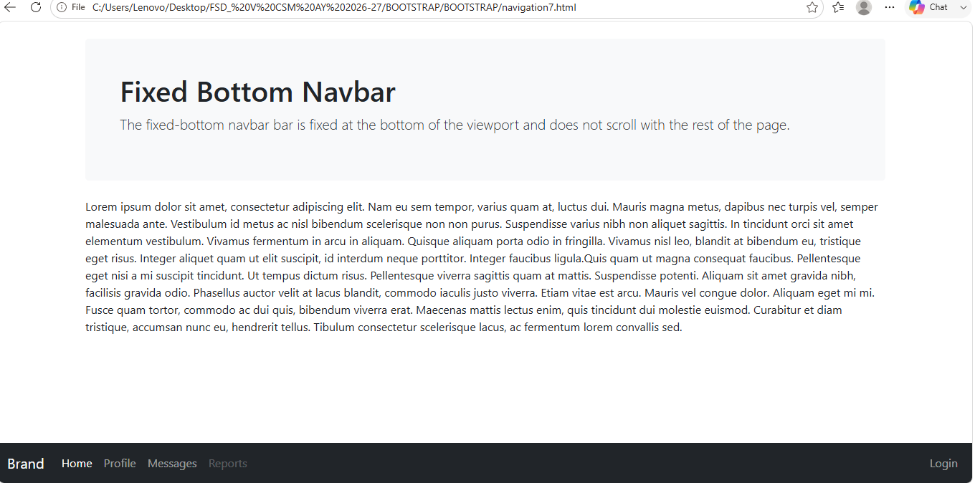

Navbar Stickied to the Top
You can also create sticky top navbar that scrolls with the page until it reaches the top, then stays there, by simply using the .sticky-top class on the .navbar element, like this:
<!DOCTYPE html>
<html lang="en">
<head>
<meta charset="utf-8">
<meta name="viewport" content="width=device-width, initial-scale=1">
<title>Bootstrap Navbar Stickied to the Top</title>
<link href="https://cdn.jsdelivr.net/npm/bootstrap@5.0.2/dist/css/bootstrap.min.css" rel="stylesheet">
<script src="https://cdn.jsdelivr.net/npm/bootstrap@5.0.2/dist/js/bootstrap.bundle.min.js"></script>
</head>
<body>
<div class="p-5 bg-warning">
<h1>Demo Header</h1>
</div>
<nav class="navbar sticky-top navbar-expand-lg navbar-dark bg-dark">
<div class="container-fluid">
<a href="#" class="navbar-brand">Brand</a>
<button type="button" class="navbar-toggler" data-bs-toggle="collapse" data-bs-target="#navbarCollapse">
<span class="navbar-toggler-icon"></span>
</button>
<div class="collapse navbar-collapse" id="navbarCollapse">
<div class="navbar-nav">
<a href="#" class="nav-item nav-link active">Home</a>
<a href="#" class="nav-item nav-link">Profile</a>
<a href="#" class="nav-item nav-link">Messages</a>
<a href="#" class="nav-item nav-link disabled" tabindex="-1">Reports</a>
</div>
<div class="navbar-nav ms-auto">
<a href="#" class="nav-item nav-link">Login</a>
</div>
</div>
</div>
</nav>

<!-- Demo Content -->
<div class="container mt-4">
<div class="p-5 mb-4 bg-light rounded-3">
<h1>Sticky Top Navbar</h1>
<p class="lead">The static-top navbar scrolls with the page until it reaches the top, then stays there.</p>
</div>
<p>navbar fixed at top this is bootstrap</p>

</body>
</html>
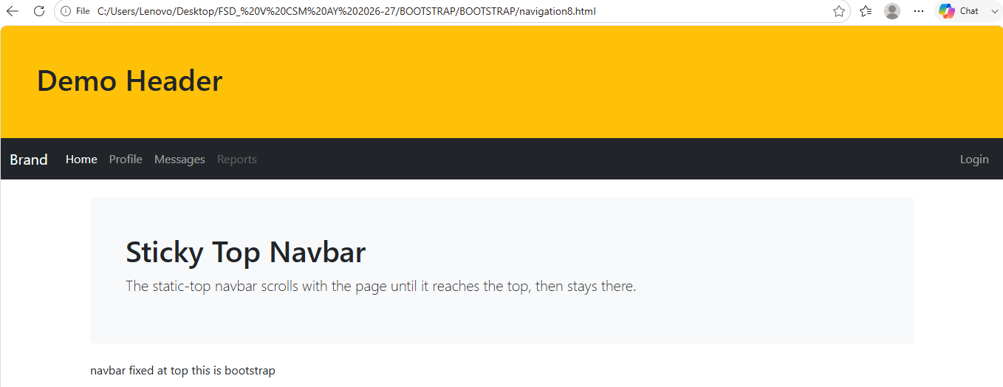

BOOTSTRAP MODAL

The Modal Plugin
The Modal plugin is a dialog box/popup window that is displayed on top of the current page:

<!DOCTYPE html>
<html lang="en">
<head>
<title>Bootstrap Example</title>
<meta charset="utf-8">
<meta name="viewport" content="width=device-width, initial-scale=1">
<link rel="stylesheet" href="https://maxcdn.bootstrapcdn.com/bootstrap/3.4.1/css/bootstrap.min.css">
<script src="https://ajax.googleapis.com/ajax/libs/jquery/3.7.1/jquery.min.js"></script>
<script src="https://maxcdn.bootstrapcdn.com/bootstrap/3.4.1/js/bootstrap.min.js"></script>
</head>
<body>

<div class="container">
<h2>Modal Example</h2>
<!-- Trigger the modal with a button -->
<button type="button" class="btn btn-info btn-lg" data-toggle="modal" data-target="#myModal">Open Modal</button>

<!-- Modal -->
<div class="modal fade" id="myModal" role="dialog">
<div class="modal-dialog">

<!-- Modal content-->
<div class="modal-content">
<div class="modal-header">
<button type="button" class="close" data-dismiss="modal">&times;</button>
<h4 class="modal-title">Modal Header</h4>
</div>
<div class="modal-body">
<p>Some text in the modal.</p>
</div>
<div class="modal-footer">
<button type="button" class="btn btn-default" data-dismiss="modal">Close</button>
</div>
</div>

</div>
</div>

</div>

</body>
</html>

Example Explained
The "Trigger" part:
To trigger the modal window, you need to use a button or a link.
Then include the two data-* attributes:
- data-toggle="modal" opens the modal window
- data-target="#myModal" points to the id of the modal
The "Modal" part:
The parent <div> of the modal must have an ID that is the same as the value of the data-target attribute used to trigger the modal ("myModal").
The .modal class identifies the content of <div> as a modal and brings focus to it.
The .fade class adds a transition effect which fades the modal in and out. Remove this class if you do not want this effect.
The attribute role="dialog" improves accessibility for people using screen readers.
The .modal-dialog class sets the proper width and margin of the modal.
The "Modal content" part:
The <div> with class="modal-content" styles the modal (border, background-color, etc.). Inside this <div>, add the modal's header, body, and footer.
The .modal-header class is used to define the style for the header of the modal. The <button> inside the header has a data-dismiss="modal" attribute which closes the modal if you click on it. The .close class styles the close button, and the .modal-title class styles the header with a proper line-height.
The .modal-body class is used to define the style for the body of the modal. Add any HTML markup here; paragraphs, images, videos, etc.
The .modal-footer class is used to define the style for the footer of the modal. Note that this area is right aligned by default.

REMOVE ADS

Modal Size
Change the size of the modal by adding the .modal-sm class for small modals or .modal-lg class for large modals.
Add the size class to the <div> element with class .modal-dialog
SMALL MODAL
<!DOCTYPE html>
<html lang="en">
<head>
<title>Bootstrap Example</title>
<meta charset="utf-8">
<meta name="viewport" content="width=device-width, initial-scale=1">
<link rel="stylesheet" href="https://maxcdn.bootstrapcdn.com/bootstrap/3.4.1/css/bootstrap.min.css">
<script src="https://ajax.googleapis.com/ajax/libs/jquery/3.7.1/jquery.min.js"></script>
<script src="https://maxcdn.bootstrapcdn.com/bootstrap/3.4.1/js/bootstrap.min.js"></script>
</head>
<body>

<div class="container">
<h2>Small Modal</h2>
<!-- Trigger the modal with a button -->
<button type="button" class="btn btn-info btn-lg" data-toggle="modal" data-target="#myModal">Open Small Modal</button>

<!-- Modal -->
<div class="modal fade" id="myModal" role="dialog">
<div class="modal-dialog modal-sm">
<div class="modal-content">
<div class="modal-header">
<button type="button" class="close" data-dismiss="modal">&times;</button>
<h4 class="modal-title">Modal Header</h4>
</div>
<div class="modal-body">
<p>This is a small modal.</p>
</div>
<div class="modal-footer">
<button type="button" class="btn btn-default" data-dismiss="modal">Close</button>
</div>
</div>
</div>
</div>
</div>

</body>
</html>

LARGE MODAL
<!DOCTYPE html>
<html lang="en">
<head>
<title>Bootstrap Example</title>
<meta charset="utf-8">
<meta name="viewport" content="width=device-width, initial-scale=1">
<link rel="stylesheet" href="https://maxcdn.bootstrapcdn.com/bootstrap/3.4.1/css/bootstrap.min.css">
<script src="https://ajax.googleapis.com/ajax/libs/jquery/3.7.1/jquery.min.js"></script>
<script src="https://maxcdn.bootstrapcdn.com/bootstrap/3.4.1/js/bootstrap.min.js"></script>
</head>
<body>

<div class="container">
<h2>Large Modal</h2>
<!-- Trigger the modal with a button -->
<button type="button" class="btn btn-info btn-lg" data-toggle="modal" data-target="#myModal">Open Large Modal</button>

<!-- Modal -->
<div class="modal fade" id="myModal" role="dialog">
<div class="modal-dialog modal-lg">
<div class="modal-content">
<div class="modal-header">
<button type="button" class="close" data-dismiss="modal">&times;</button>
<h4 class="modal-title">Modal Header</h4>
</div>
<div class="modal-body">
<p>This is a large modal.</p>
</div>
<div class="modal-footer">
<button type="button" class="btn btn-default" data-dismiss="modal">Close</button>
</div>
</div>
</div>
</div>
</div>

</body>
</html>

